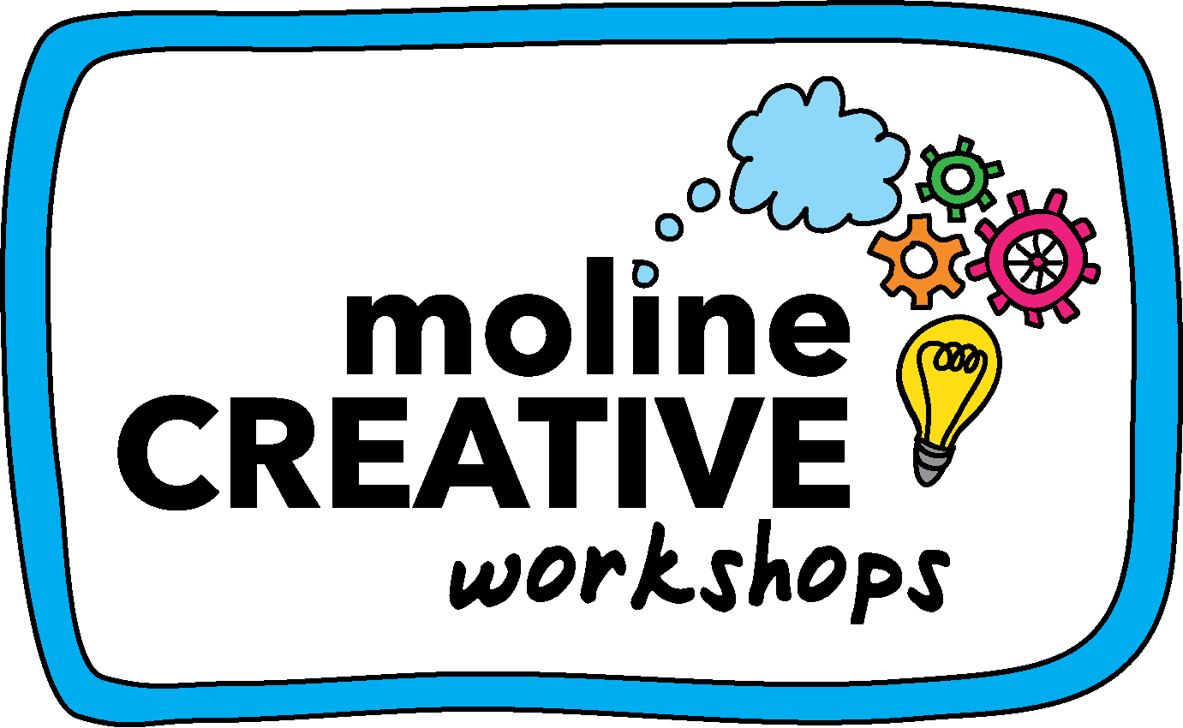
2023 CONTAGIOUS CREATIVITY AWARDS
www.molinecreative.com/contagiouscreativity

The Contagious Creativity Awards serve not-for-profit organizations that are doing good work but cannot otherwise afford Moline Creative’s services.

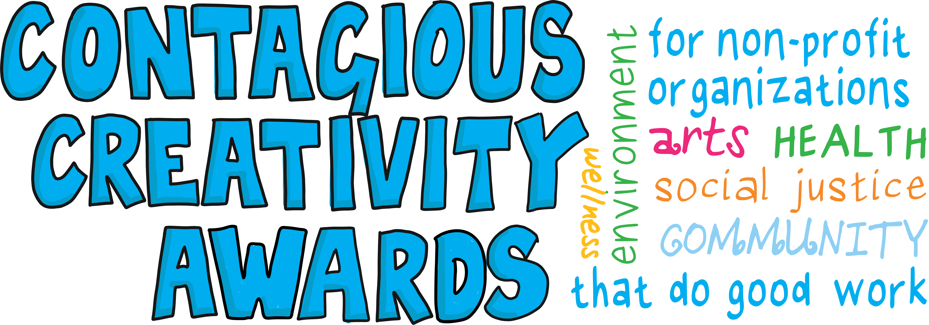

LEADERSHIP TEAM RETREAT WORKSHOP
- Award: Facilitated 4-hour Leadership Team Workshop in Flagstaff, AZ
  - Two pre-workshop planning meetings via phone / Zoom to clarify your goals, participant list, agenda, and logistics
  - Stakeholder phone interviews (up to three calls) or virtual survey
  - 4-hour facilitated virtual session with your leadership team (in person or via Zoom)
  - PDF report of completed visual notes that includes decisions and includes next steps
- Application process: Complete this application form and email to angie@molinecreative.com
- Application Deadline: May 5, 2023 by midnight MST.
- Award Notification: May 15, 2023
- Date Confirmation: May 22, 2023
- Workshop Completion: August 15, 2023

Eligibility: All not-for-profit organizations that attend the Northern Arizona Center for Nonprofit Entrepreneurship 2023 Conference are eligible to apply for the 2023 Contagious Creativity Awards. Organizations do not need to be registered 501(c)(3) non-profits.

Selection Criteria:
- Applications will evaluated on the organization’s purpose, clarity of workshop goals, and beneficial impact to Arizona.
- We are open to any proposed goals. Past CC awardees have clarified core values, refined their purpose, delineated roles, visualized their workflow, and explored barriers to inclusion.
- You may define “Leadership team” however it makes the most sense for your organization. Some organizations have worked with their boards on high-level strategy and others have done operational / tactical work with their staff.
- There is no restriction on the size of organizations that may apply, but we tend to fund tiny organizations (e.g., < 5 paid staff and < $500K in gross receipts – usually much less).
- Contagious Creativity Awards are intended to help our community thrive, so interesting, fun, and socially or environmentally relevant applications will rank highly.

Fine Print
- Proposals that are incomplete or do not follow the format will not be evaluated.
- Sessions (e.g. planning meetings and workshops) must be completed by August 15, 2023.
- These awards cover Moline Creative services, but not meeting expenses or supplies (e.g. printing, photocopies of templates, lunch, snacks); those costs will be paid by the awardee.
- Your organization must find a location for our session! In Flagstaff, NACET and The Red Door Meeting Space are both excellent and affordable.
- Moline Creative honors confidentiality and nondisclosure agreements for work that is sensitive or proprietary.
- Moline Creative retains the copyright to all original work, but clients may reproduce visual notes with attribution.

2023 CONTAGIOUS CREATIVITY AWARDS
APPLICATION

www.molinecreative.com/contagiouscreativity

Instructions: Applicants should answer the following questions, but not provide any additional information beyond what is requested here. Proposals will be scored based on the organization’s mission and the clarity of meeting goals / impact on making the world a better place; interesting, fun, and socially or environmentally relevant applications will rank highly. Applicants who are not familiar with Moline Creative will want to watch this 3-minute video at www.molinecreative.com/about.html

Questions may be directed to the angie@molinecreative.com.

Note: Scheduling workshops is the most difficult part of actualizing the Contagious Creativity Awards. Therefore, please work with your attendees to identify and hold three dates that could be used for a 4-hour workshops (five hours if you’d like to take a lunch break). The date will be confirmed by May 22.

Proposals shall be submitted as a PDF document via email to angie@molinecreative.com by midnight (MST) on May 5, 2023.

CONTAGIOUS CREATIVITY AWARDS APPLICATION INFORMATION

Organization Name: _______________________________ Website: __________________________________
Proposal Contact Person: __________________________ Email: _______________ Phone: ______________
Meeting Contact:* _________________________________ Email: _______________ Phone: ______________
* Ideally this is the final decision-maker for the meeting outcomes, decisions, and implementation.

What are your organization’s mission and purpose? _____________________________________________
____________________________________________________________________________________________

What 1-3 key objectives could Moline Creative help your team accomplish during the meeting? ____________________________________________________________________________________________

The most important question: Describe how working with Moline Creative during a visual workshop would help your organization make the world a better place? (1000 words or less)

Generally who would attend this workshop (i.e. staff, board members, public)? _____________________

My non-profit team is currently holding these three dates (between June 1 – August 15, 2023) for our workshop:
- _________________________ 2. _________________________ 3. _________________________

In general, this time frame works best for our team: Morning – Afternoon - Evening

Application Deadline: May 5, 2023.

www.molinecreative.com/contagiouscreativity

